**Interfacing DC Motor with PIC Microcontroller**

STUDENT NAME: G.P.D. THAMARA

STUDENT NUMBER: EC/2021/005

**Source Code**

sbit Forward at RA0_bit;

sbit Reverse at RA1_bit;

sbit Brake at RA2_bit;

void main() {

CMCON = 0x07;

TRISA = 0x07;

TRISB = 0x00;

PORTB = 0x00;

while(1) {

if (!Forward) {

PORTB = 0x00;

RB0_bit = 1;

RB1_bit = 0;

RB2_bit = 1;

}

else if (!Reverse) {

PORTB = 0x00;

RB0_bit = 1;

RB1_bit = 1;

RB2_bit = 0;

}

else if (!Brake) {

PORTB = 0x00;

}

}

}

**Circuit**

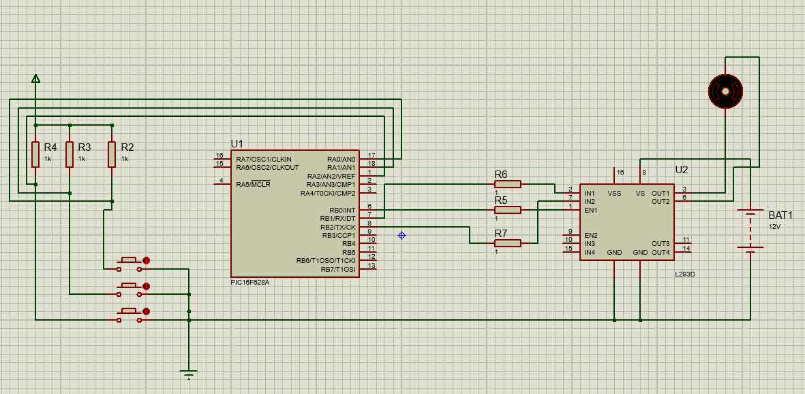

**Observations**

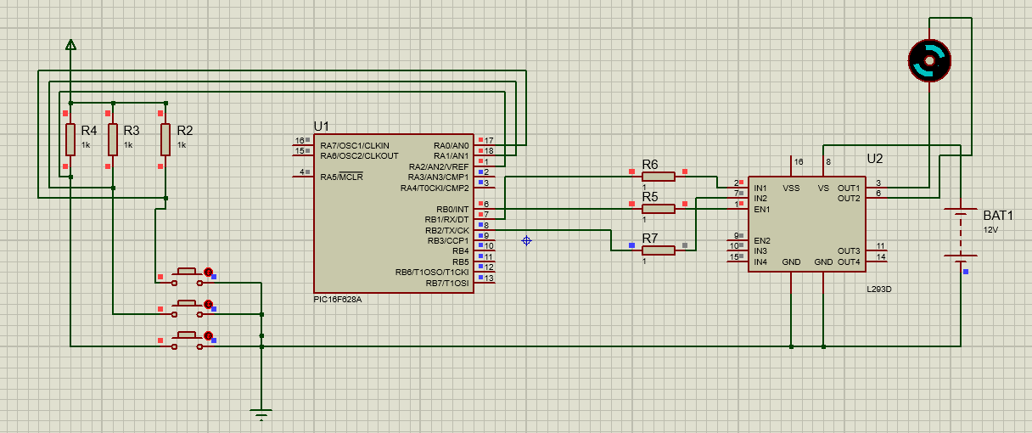

For one button motor is rotating clockwise, other button rotating anticlockwise and for the third button motor stops rotating.

**Discussion**

The experiment successfully demonstrated the method of interfacing a DC motor with a PIC microcontroller using an L293D motor driver IC to achieve bi-directional control. This setup emphasized a critical principle in embedded system design: the need for intermediary driver circuits when controlling high-power components like motors with low-power devices such as microcontrollers.

Since microcontroller output pins cannot provide the necessary current and voltage required by a DC motor and are vulnerable to back EMF the L293D IC played a crucial role as a buffer and controller. Its dual H-bridge configuration allowed the motor to rotate in both clockwise and counterclockwise directions, depending on the logic levels applied to its input pins from the microcontroller. This behavior was validated through the programmed control logic and direction-switching observed during testing.

Additionally, the built-in clamp diodes in the L293D protected the circuit from voltage spikes caused by inductive loads during motor switching. Without this protection, components 1, especially the microcontroller, could be permanently damaged. The TTL-compatible inputs of the L293D made interfacing with the PIC microcontroller straightforward and efficient, requiring no additional logic-level conversion circuitry.

One important observation during the experiment was the necessity of supplying an adequate external power source to the motor through the L293D’s VCC2 pin. Failure to do so would result in weak or no motor rotation, despite the microcontroller logic being correct. This highlights the importance of separating logic-level and motor-level power supplies in motor driver applications.

This experiment not only showed how to drive a DC motor safely using a microcontroller but also reinforced the importance of voltage level matching, inductive protection, and driver circuitry in embedded hardware design. The knowledge gained from this experiment is directly applicable to real-world automation, robotics, and control systems where motor control is essential.